**Module**: **Internet of Things - CSC8112**

**Yash Gadodia - 240679307**

Aim

The aim of this coursework is to develop an Internet of Things (IoT) data processing pipeline that processes sensor data in an edge-cloud environment. The pipeline will be designed to perform operations such as data collection, preprocessing, visualization, and prediction by leveraging lightweight virtualization technology, specifically Docker. This setup will enable the integration of edge and cloud resources to support the implementation of a machine learning-based IoT pipeline, ultimately facilitating air quality predictions from urban data.

Introduction

The rapid expansion of IoT technologies has revolutionized the way urban environments are monitored and managed, providing real-time data that can inform decision-making and enhance the quality of life in cities. This coursework focuses on developing an IoT data processing pipeline that operates across both edge and cloud tiers, utilizing data from the Newcastle Urban Observatory (NCT UO). The NCT UO serves as a pivotal source of diverse, real-time urban data, encompassing over 50 distinct data types collected from sensors distributed throughout Newcastle city.

The proposed pipeline is architected to facilitate efficient data flow from the IoT tier to the cloud tier, encompassing several key components and stages:

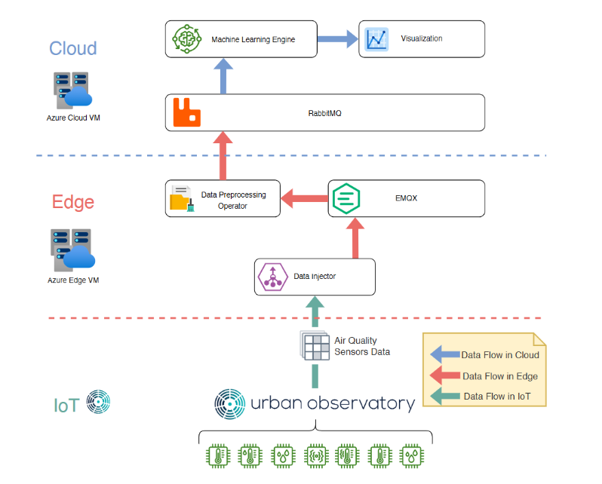

1. **IoT Tier:**
   * **Newcastle Urban Observatory (NCT UO):** Acts as the primary data source, providing a rich set of real-time urban metrics.
2. **Edge Tier:**
   * **Data Injector:** A custom-developed software component responsible for interfacing with the NCT UO API to ingest data and transmit it to the machine learning pipeline.
   * **EMQX Broker:** Utilizes the MQTT protocol to enable asynchronous communication between services, ensuring reliable message queuing within the pipeline.
   * **Data Pre-processing Operator:** Processes raw data to prepare it for machine learning model training, ensuring data quality and relevance.
3. **Cloud Tier:**
   * **RabbitMQ:** Serves as a cloud-based message queuing system to manage data flow and communication between cloud services.
   * **Machine Learning Model/Classifier/Engine:** Trains on pre-processed data to predict future events, leveraging real-world data streams from the NCT UO.
   * **Visualization Component:** Generates graphical representations of both raw time-series data and predictive analytics, facilitating intuitive data interpretation.

The integration of Docker as the virtualization technology stack enables the deployment of these components as microservices, promoting scalability, flexibility, and ease of management. Throughout this coursework, emphasis is placed on hands-on implementation using command-line interfaces and Python programming to configure Docker-based services, pull necessary images from Docker Hub, and develop machine learning models tailored to urban data streams.

Implementation

**Task 1: Design a data injector component by leveraging Newcastle Urban Observatory IoT data streams**

1. Pull and run the Docker image "emqx/emqx" from Docker Hub in the virtual machine running on Azure lab (Edge). Perform this task first using the command line interface (CLI).

**To initiate the EMQX broker on the Edge layer, we use the command:**

***docker pull emqx/emqx***

***docker run -d --name emqx -p 18083:18083 -p 1883:1883 emqx/emqx:latest***

**This command pulls the latest EMQX image from Docker Hub and runs it as a container in detached mode, mapping the default MQTT port (1883) on the host.**

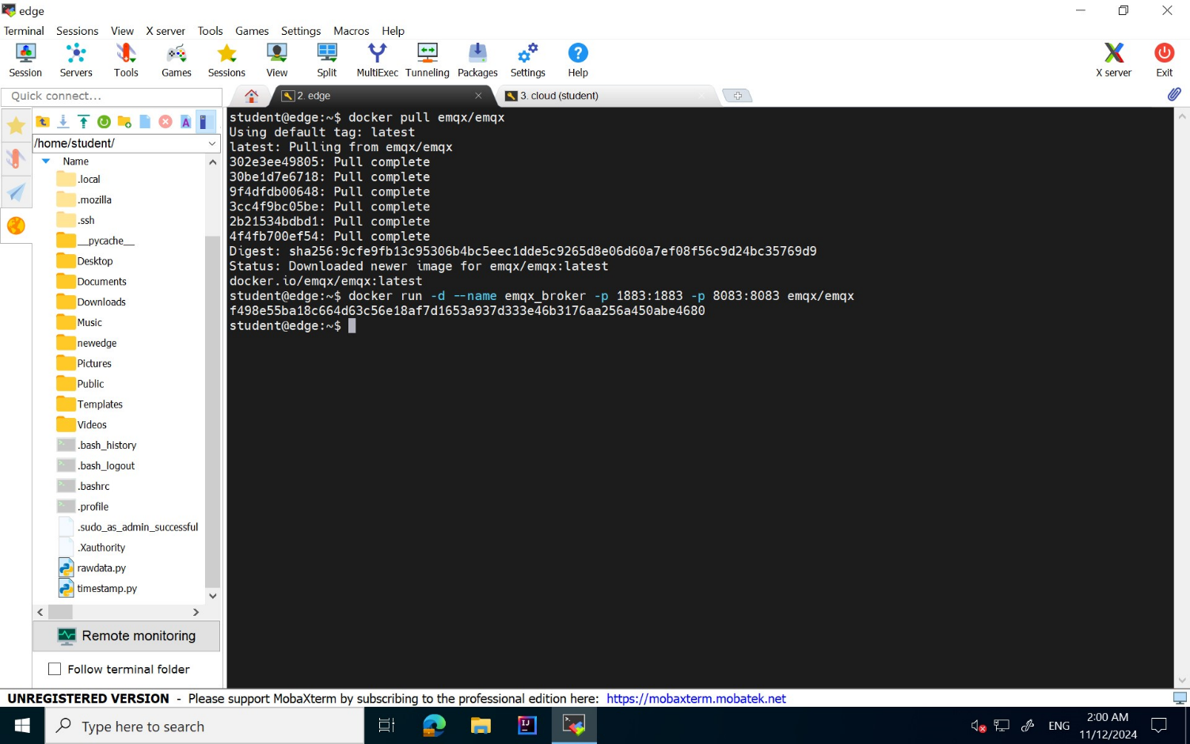

Figure 1.1

1. Develop a data injector component with the following functions (Code) in Azure Lab (Edge) or the Azure Lab localhost:
2. Collect data from Urban Observatory platform by sending HTTP request to the following url **([[Urbanobservatory](https://newcastle.urbanobservatory.ac.uk/api/v1.1/sensors/PER_AIRMON_MONITOR1135100/data/json/?starttime=20230601&endtime=20230831)]).** Following that, please print out the raw data streams that you collected on the console.

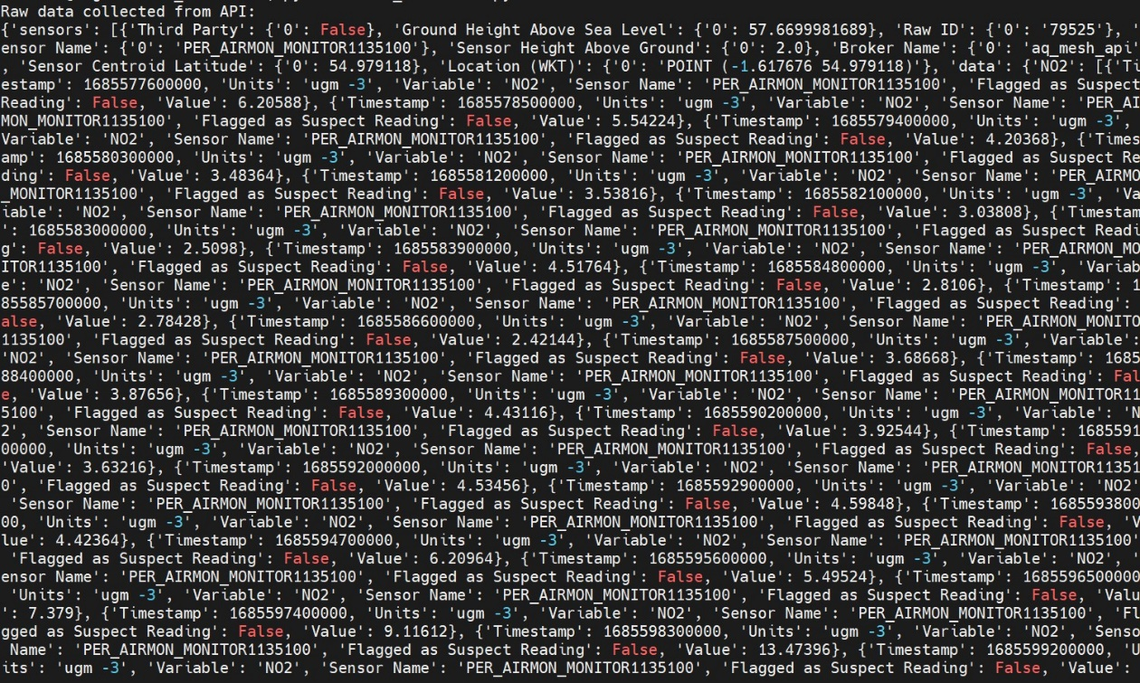**The figure below displays the output after executing the data collector, showing that raw data has been successfully retrieved from the Newcastle Urban Observatory.**

Figure 1.2

1. Although the raw air quality data you collected from the Urban Observatory API

contains many metrics including N O2, NO, CO2, PM2.5, and PM10, among others,

for the purpose of this coursework, you only need to store and analyze PM2.5 data.

While many meta-data are available for PM2.5 data, such as sensor name, timestamp,

value, and location, you only need to store the metrics related to the Timestamp and

Value meta-data fields.

**We filter the data obtained from the Urban Observatory API to retain only the timestamp and value metadata fields, which are then displayed on the console.**

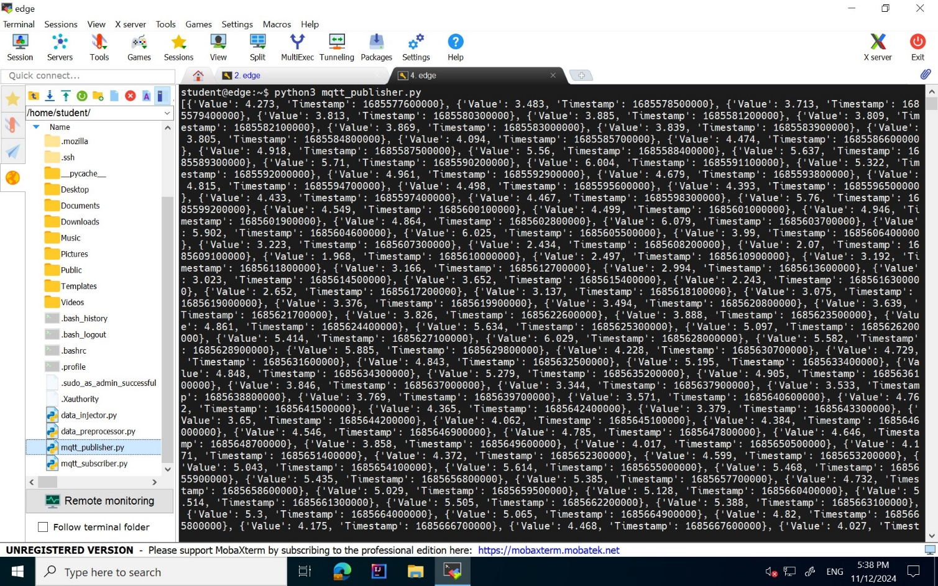

Figure 1.3

1. Send all PM2.5 data to be used by Task 2.2 (a) to EMQX service of Azure lab (Edge).

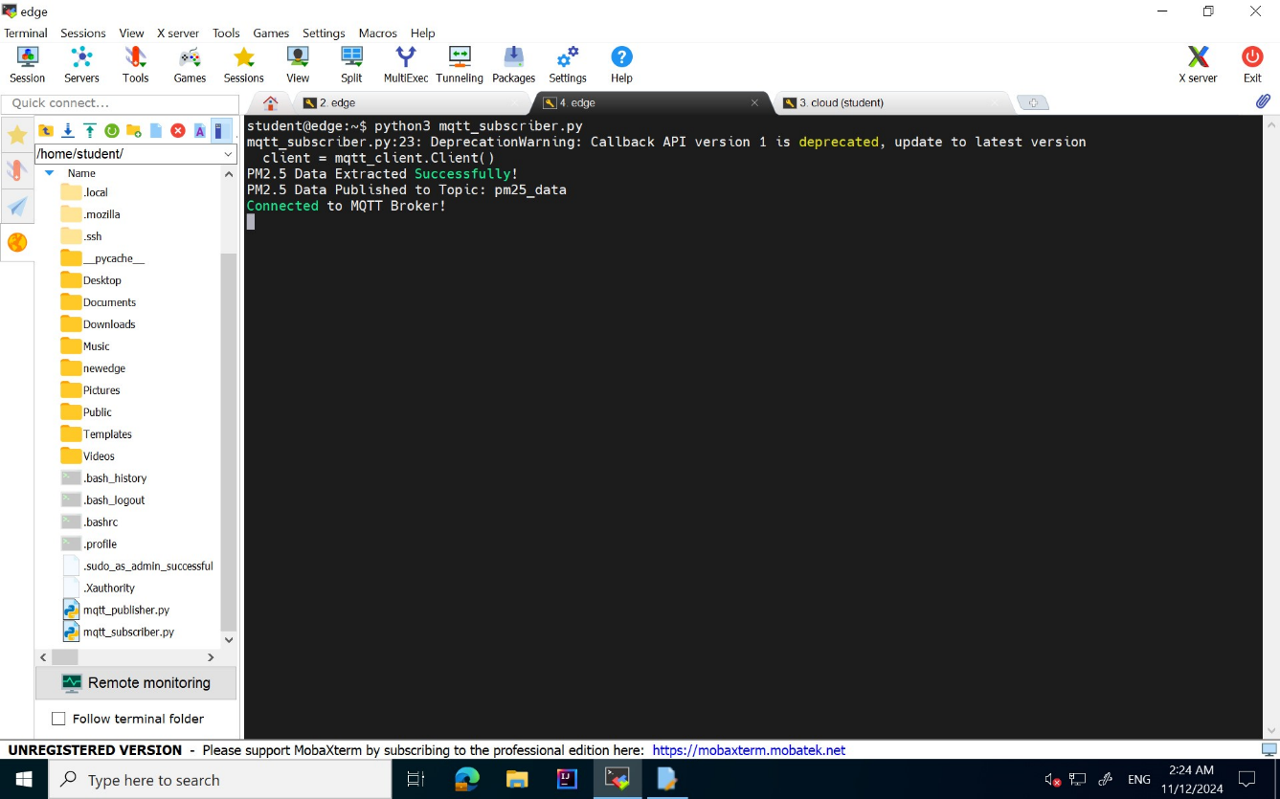

Figure 1.4

**Screenshots**:

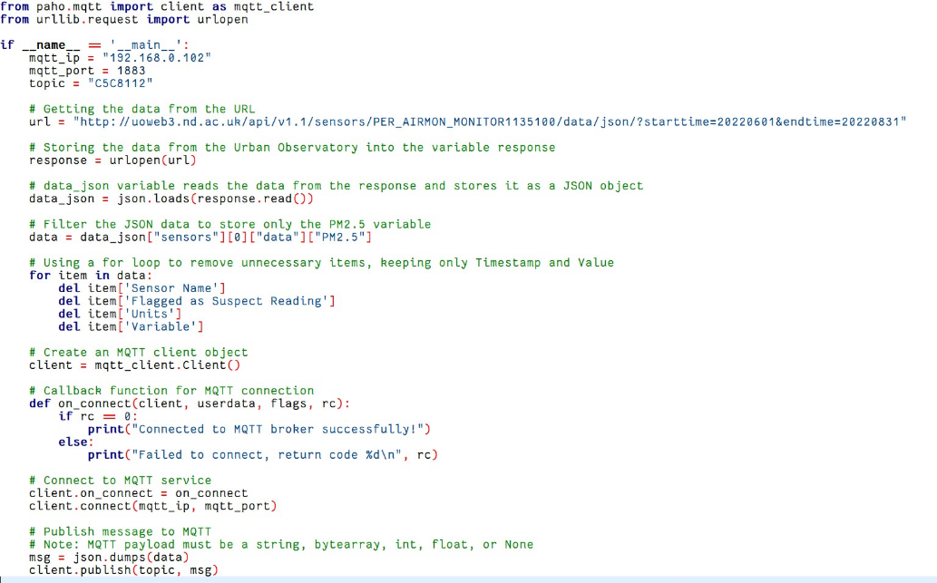

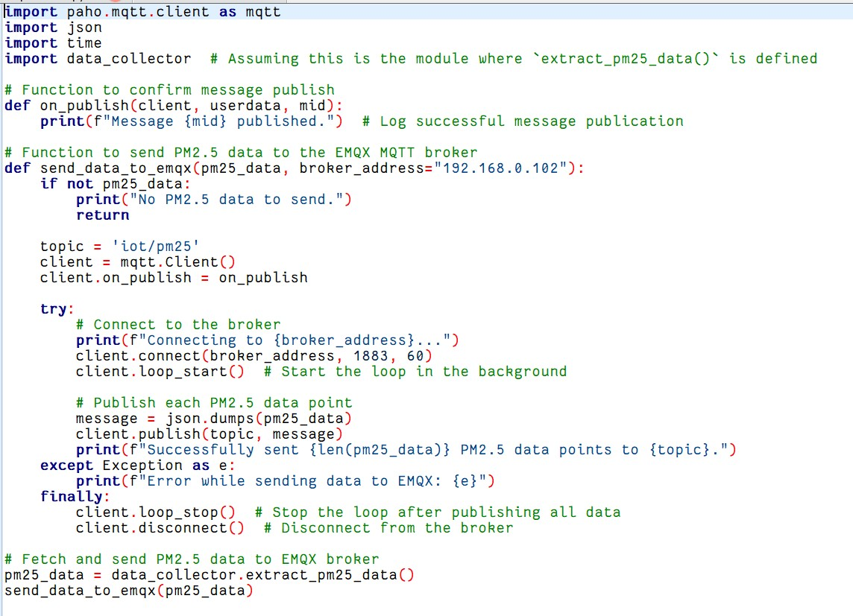

In this task, I pulled and ran the EMQX Docker image on an Azure VM using CLI commands, setting up a scalable MQTT broker for IoT data handling (Figure 1.1). I developed two Python scripts: data collector to fetch air quality data from the Urban Observatory API and print the collected data, and emqx publisher to filter only the PM2.5 data, extracting timestamp and value fields, and publishing this filtered data to EMQX using the paho-mqtt library. Figures 1.3 and 1.4 show the filtered data output and successful publishing

**Task 2: Data preprocessing operator design**

1. Define a Docker compose file which contains the following necessary configurations and instructions for deploying and instantiating the following set of Docker images on Azure lab (Cloud):

**The figure below shows the Docker file created to run the RabbitMQ Docker image with specified port configurations.**

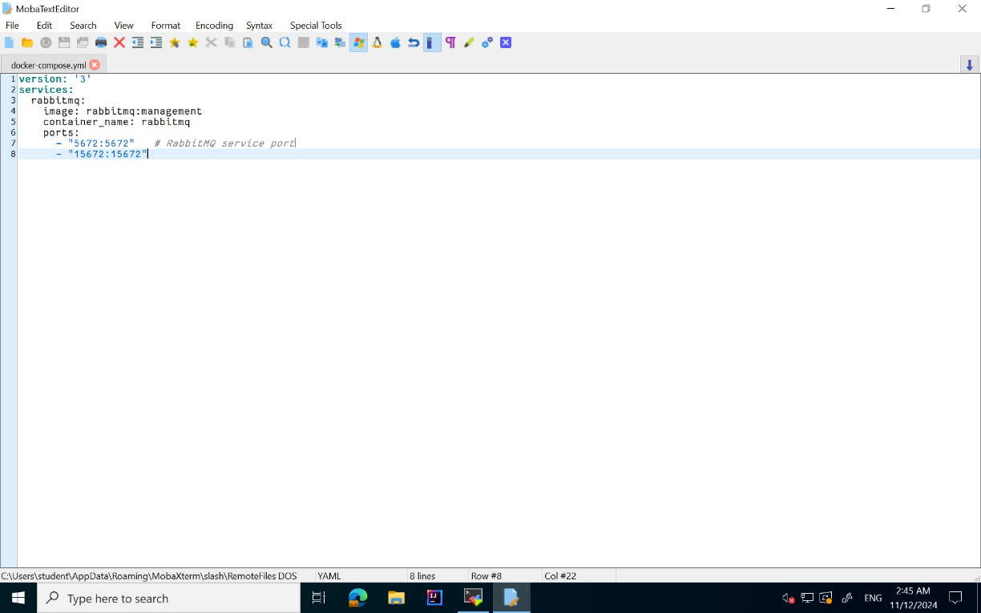

Figure 2.1

1. Download and run RabbitMQ image (rabbitmq: management)

**The image below displays the RabbitMQ container running on Azure Lab (Cloud) after executing the `docker-compose up` command in the cloud environment.**

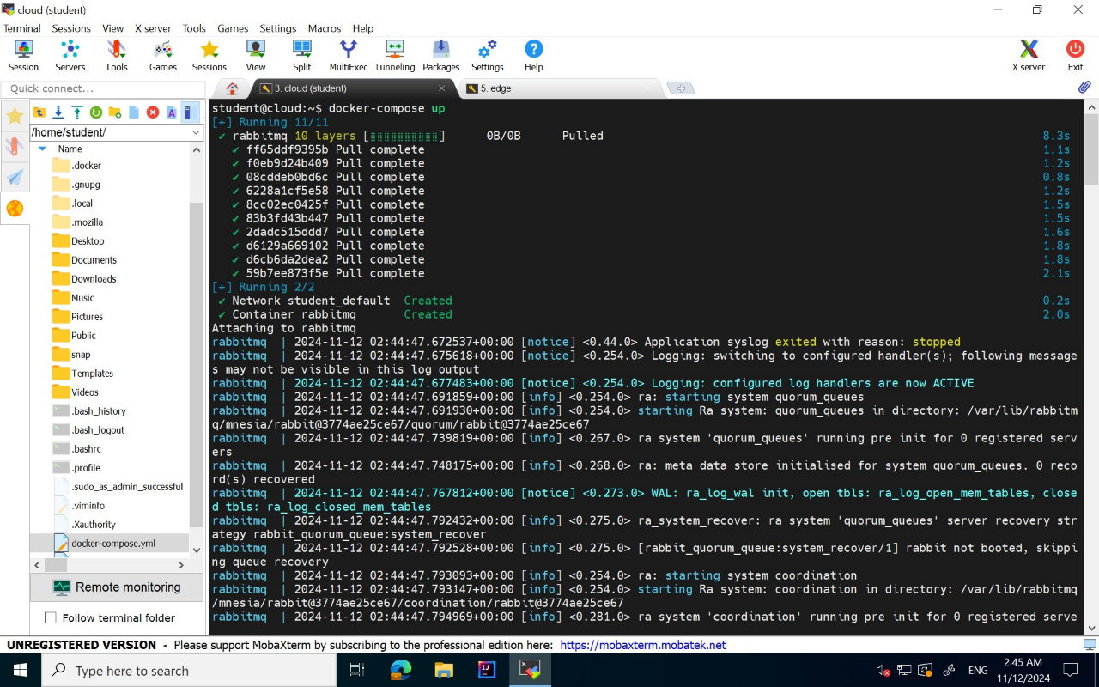

Figure 2.2

1. Design a data preprocessing operator with the following functions (code) in Azure Lab (Edge):
2. Collect all PM2.5 data published by Task 1.2 from EMQX service, and please print out the PM2.5 data to the console (this operator will run as a Docker container, so the logs can be seen in the docker logs console automatically).

**Connects to the EMQX broker in order to use paho-mqtt to gather the PM2.5 data. After connecting to the broker, the subscriber will print the necessary dataset.**

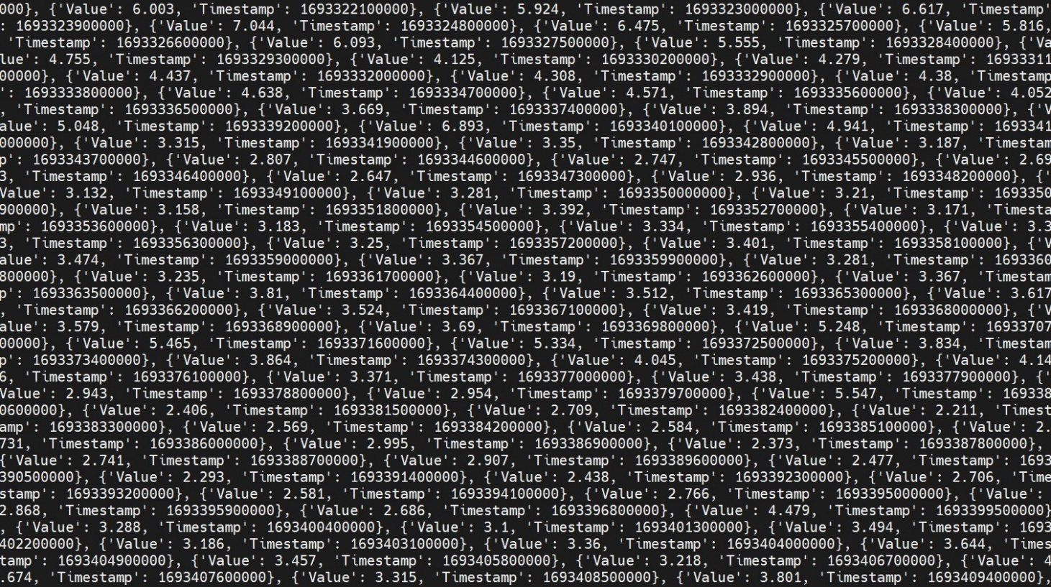

Figure 2.1

1. Filter out outliers (the value greater than 50), and please print out outliers to the console (docker logs console).

**We filter out any PM2.5 data values greater than 50 as outliers and print the remaining values to the Docker logs console.**

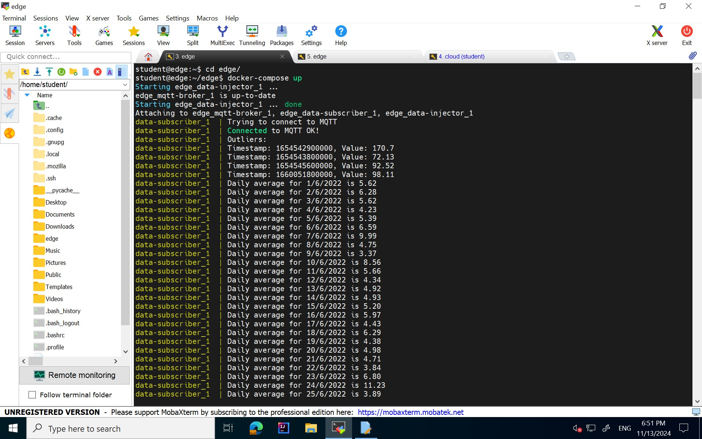

Figure 2.2

1. Since the original PM2.5 data readings are collected every 15 mins, so please implement a python code to calculate the averaging value of PM2.5 data on daily basis (every 24 hours), please pick the first start date of a day or a 24 hours interval as the new timestamp of averaged PM2.5 data, and please print out the result to the console (docker logs console).

**The collected data is then averaged over a 24-hour period to generate a new timestamp for the PM2.5 data, and the output is displayed on the Docker console.**



Figure 2.3

1. Transfer all results (averaged PM2.5 data) to be used by Task 3.2 (a) into RabbitMQ service on Azure lab (Cloud).

**The output generated from the pre-processor code is then transmitted to the Azure Lab (Cloud) via the RabbitMQ publisher**

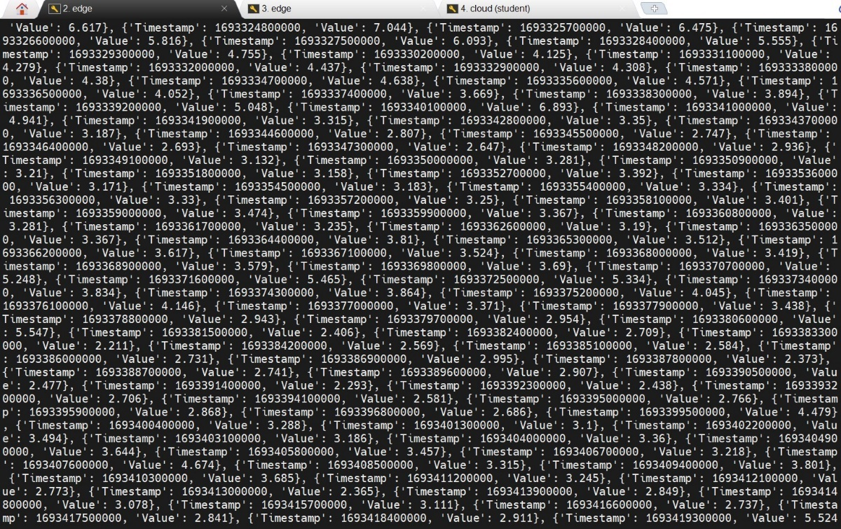

Figure 2.4

1. Define a Dockerfile to migrate your "data preprocessing operator" source code into a Docker image and then define a docker-compose file to run it as a container locally on the Azure lab (Edge).

**Screenshots:**

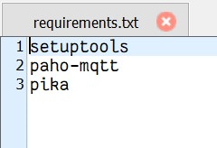

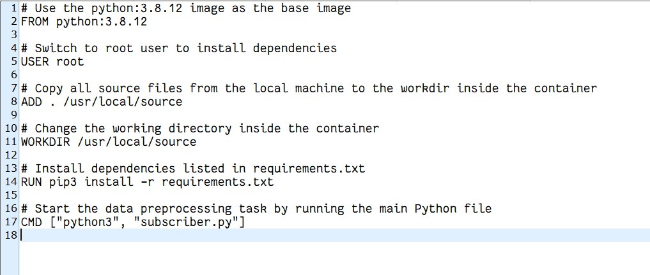

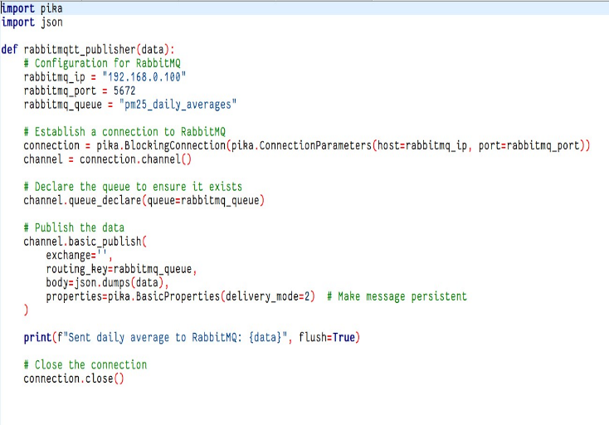

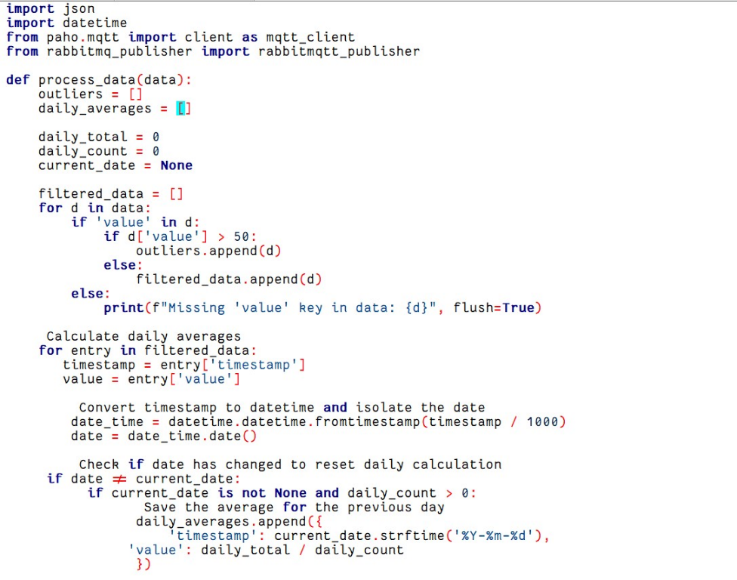

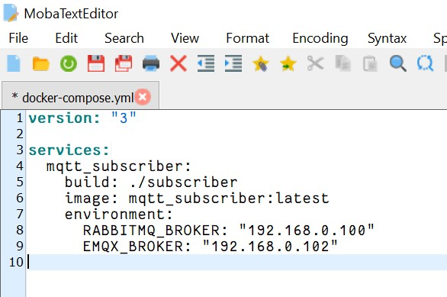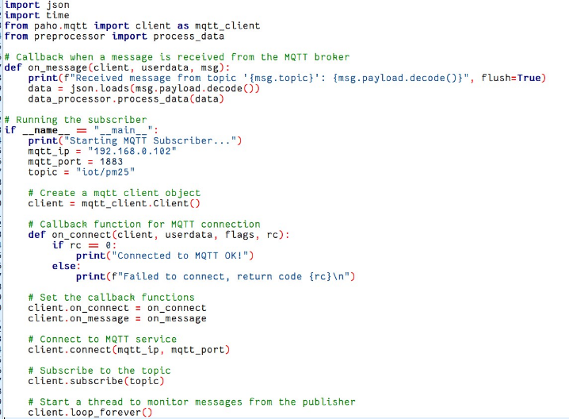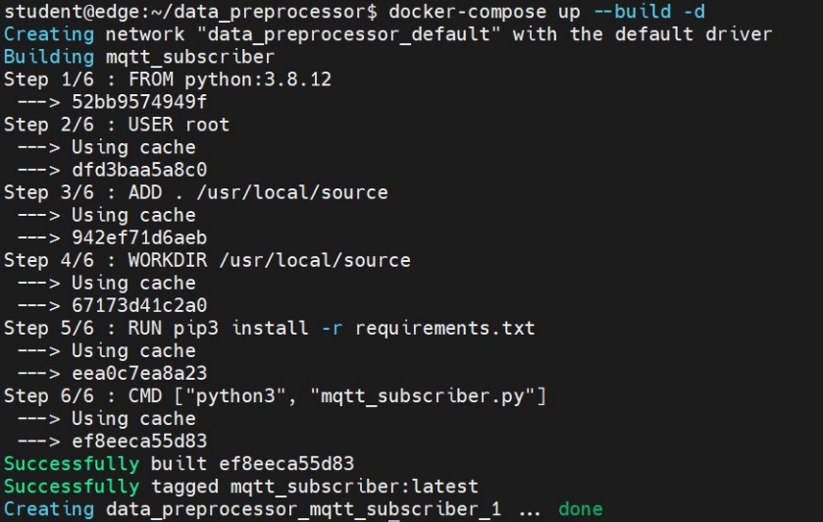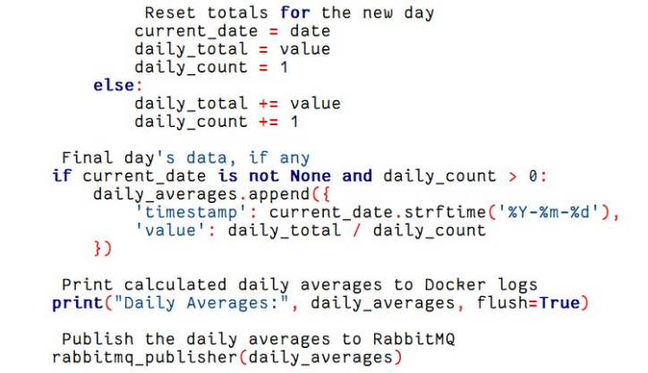

**Task 3: Time-series data prediction and visualization**

1. Download a pre-defined Machine Learning (ML) engine code from [https://github.com/ncl-iot-team/CSC8112_MLEngine].

**We download and utilize a pre-existing machine learning code to make predictions on the data.**

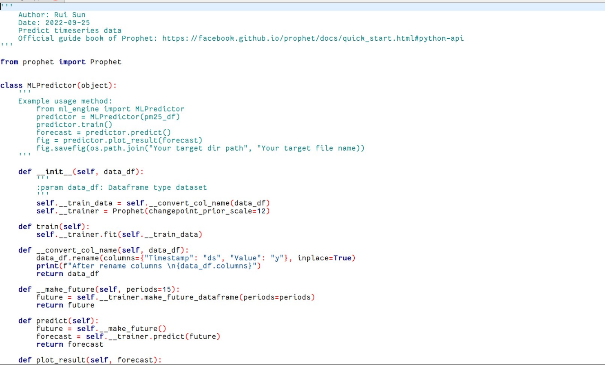

1. Design a PM2.5 prediction operator with the following functions (code) in Azure Lab (Cloud) or the Azure Lab localhost:
2. Collect all averaged daily PM2.5 data computed by Task 2.2 (d) from RabbitMQ service, and please print out them to the console.

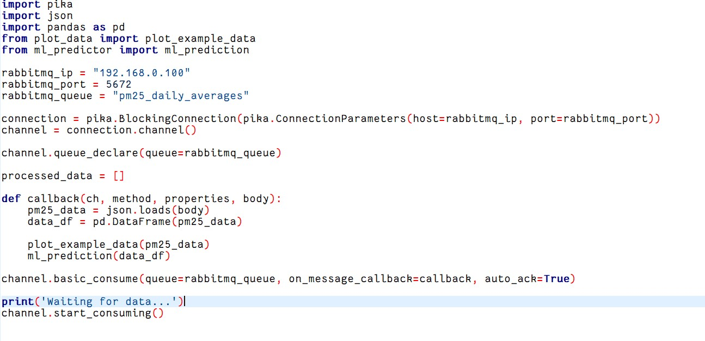**We execute the rabbitmq_consumer.py code, which collects all the data published by the RabbitMQ service and prints the results to the console.**

1. Convert timestamp to date time format (year-month-day hour:minute:second), and please print out the PM2.5 data with the reformatted timestamp to the console.

**We convert the obtained data into a date-time format by passing it to the process function, as outlined in the below above.**

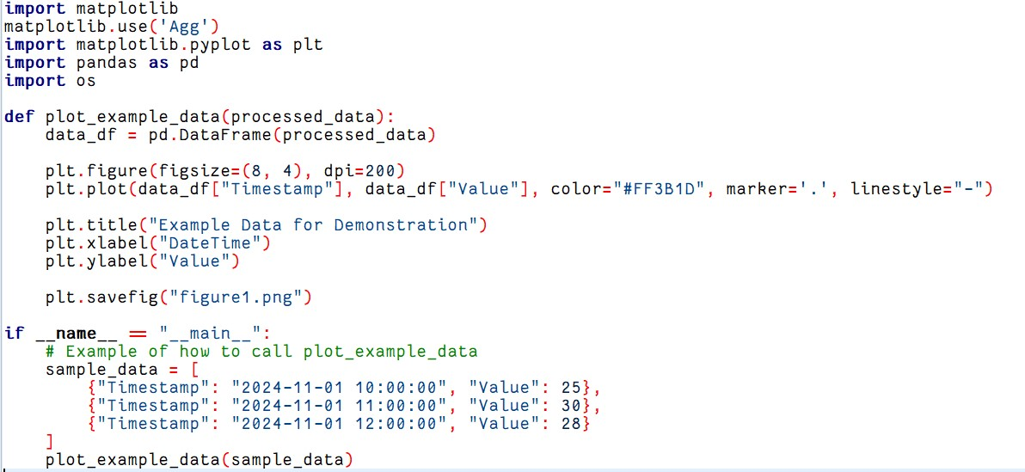

1. Use the line chart component of matplotlib to visualize averaged PM2.5 daily data, directly display the figure or save it as a file.

**The averaged PM2.5 daily data is passed to the function, where it is represented visually using matplotlib.**

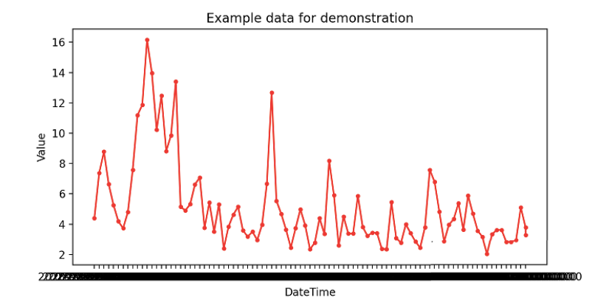

1. Feed averaged PM2.5 data to machine learning model to predict the trend of PM2.5 for the next 15 days (this predicted time period is a default setting of provided machine learning predictor/classifier model).

**The average daily PM2.5 data is then input into the provided machine learning model (mentioned in Task 3, Part 1) to predict the PM2.5 levels for the next 15 days.**

1. Visualize predicted results from Machine Learning predictor/classifier model, directly display the figure or save as it a file (pre-defined in the provided Machine Learning code).

**Once the machine learning model was implemented, we were able to generate a visual representation of the predicted PM2.5 data for the next 15 days.**

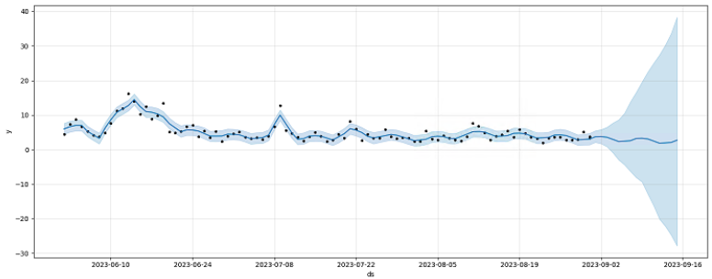

**Screenshots**:

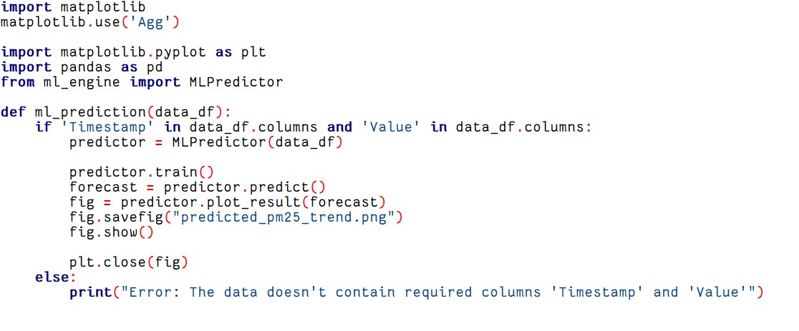

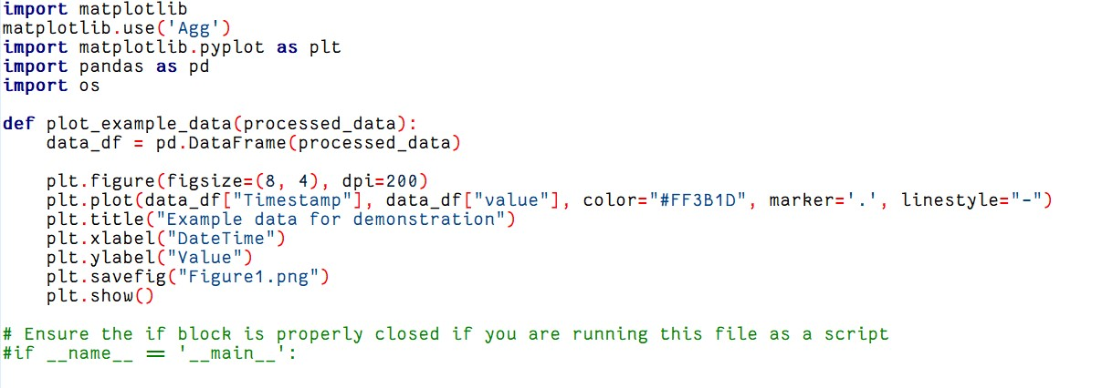

Analytical Discussion:

In this project, we gained valuable insights into the PM2.5 data over time and generated predictions showing a decline in PM2.5 values over the next 15 days. The PM2.5 graph revealed that the highest concentration occurred in June, followed by a gradual decrease through November.

Conclusion:

This project allowed us to implement an IoT pipeline using two different messaging systems (EMQX and RabbitMQ), functioning across the Azure Edge and Azure Cloud layers. It provided a deeper understanding of IoT principles and demonstrated the use of various tools, such as Docker, to containerize code into lightweight images that run on the edge layer for efficient computation. The project has enhanced my knowledge of different modules and techniques needed to implement a basic IoT pipeline.

References:

* [Stackoverflow](https://stackoverflow.com/%20)– For resolving implementation-related queries.
* [Docker](https://docker-curriculum.com/%20)– Docker documentation.
* [Github](https://github.com/ncl-iot-team/CSC8112%20)- For various code references and set-up of pipeline